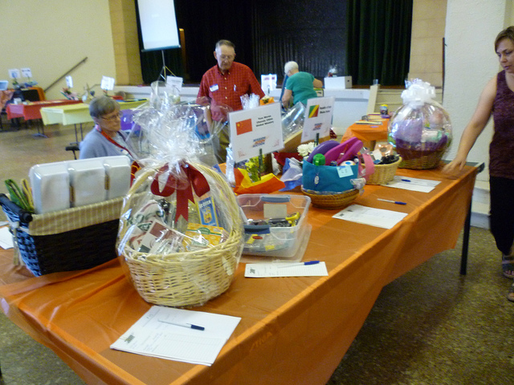
BENEFIT BRUNCH FOR AUTISM
Sunday, November 25, 2018 – 11:30 AM – 2:30 PM
Sala San Marco Centre (215 Preston Street)
**SILENT AUCTION OPENS AT 11 AM**
Tickets are $40 Adults, $25 Children ages 5-12 (under 5 free)
Children at Risk -741-8255
Enjoy a superb Brunch, listen to the seasonal, soothing sounds of
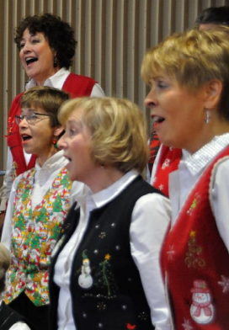
We are also delighted to welcome again students from the
National Capital Suzuki School of Music! 
MASTER OF CEREMONIES: PATRICIA BOAL, CTV OTTAWA NEWS
Organized by The King’s Daughters and Sons to raise funds for
Children at Risk and Autism Supports in the Ottawa Area.

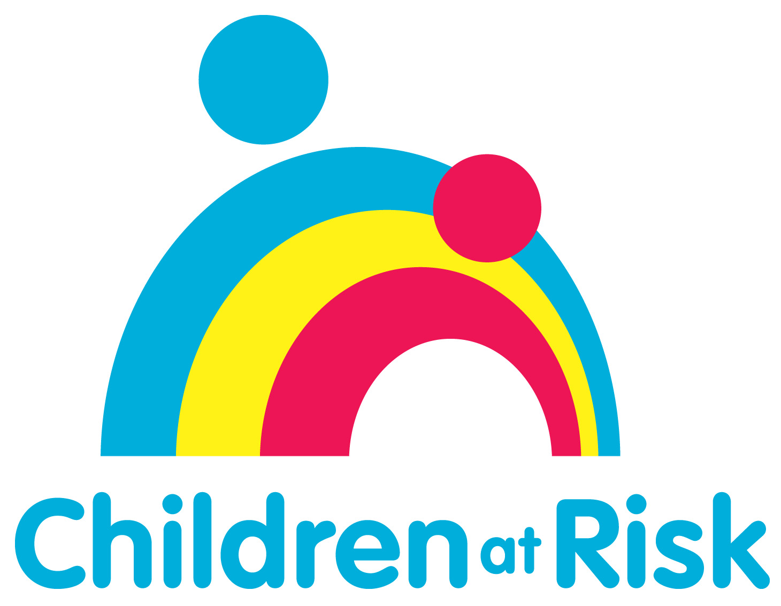 , Ottawa  www.childrenatrisk.ca | 

