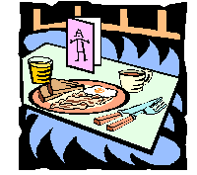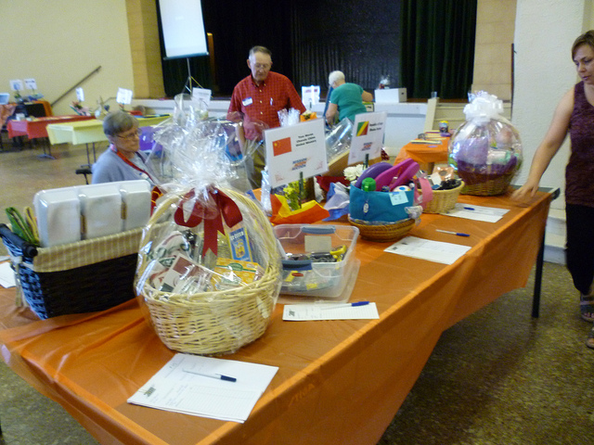
BENEFIT BRUNCH FOR AUTISM
Sunday, November 12, 2017 – 11:30 AM – 2:30 PM
**NEW LOCATION: Sala San Marco Centre (215 Preston Street)
**SILENT AUCTION OPENS AT 11:30 AM**
Tickets are $35 Adults, $20 Children ages 5-12 (under 5 free)
Children at Risk -741-8255
Enjoy a superb Brunch, listen to the soothing sounds of
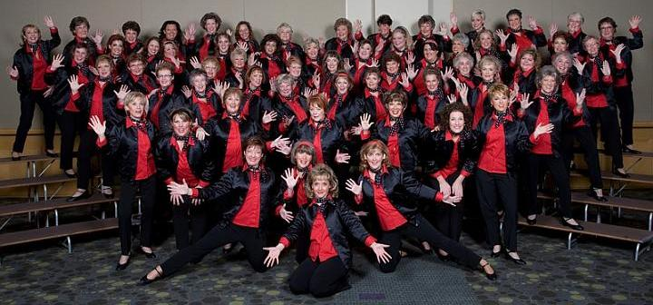

We are also delighted to welcome Regan & Hilary, students from the
National Capital Suzuki School of Music! 
MASTER OF CEREMONIES: PATRICIA BOAL, CTV OTTAWA NEWS
Organized by The King’s Daughters and Sons to raise funds for
Children at Risk and Autism Supports in the Ottawa Area.
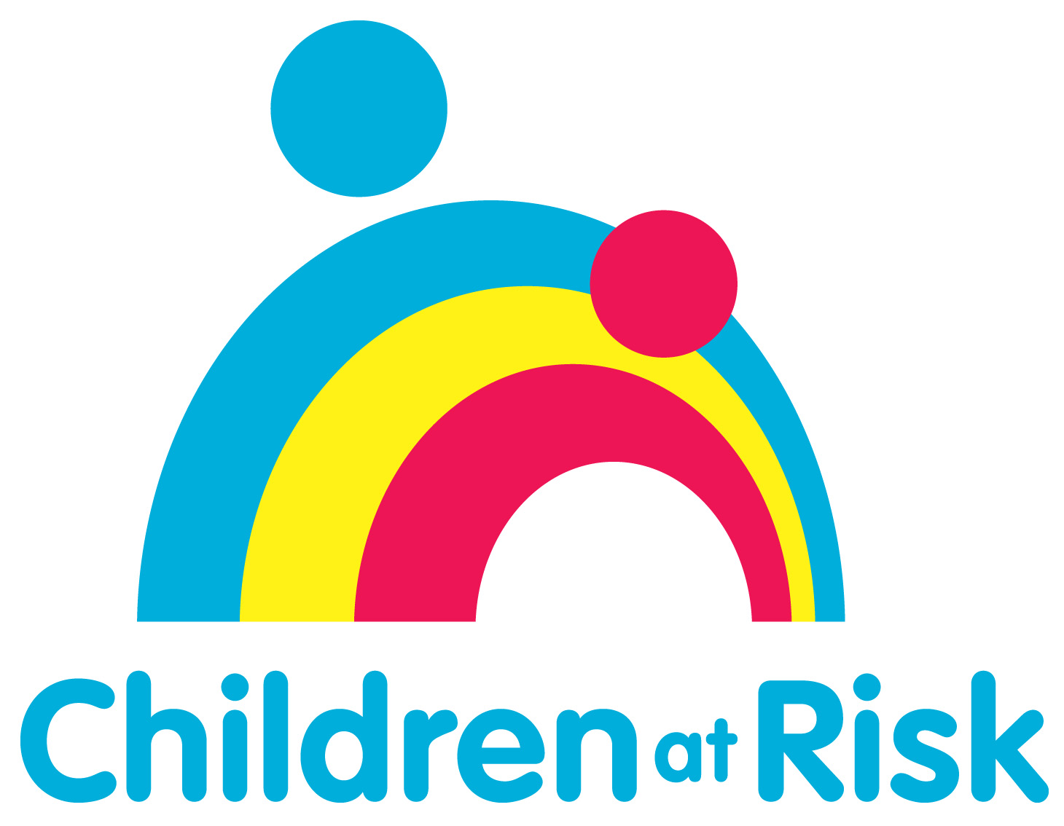 , Ottawa  www.childrenatrisk.ca | 

